CHAPTER 8

ESTIMATION AND HYPOTHESIS TESTING

- Inference is the process of making interpretations or conclusions from sample data for the totality of the population.
- It is only the sample data that is ready for inference.
- In statistics there are two ways though which inference can be made.
  - Statistical estimation
  - Statistical hypothesis testing.
Statistical Estimation
This is one way of making inference about the population parameter where the investigator does not have any prior notion about values or characteristics of the population parameter.
There are two ways estimation.
- Point Estimation
It is a procedure that results in a single value as an estimate for a parameter.
- Interval estimation
It is the procedure that results in the interval of values as an estimate for a parameter, which is interval that contains the likely values of a parameter. It deals with identifying the upper and lower limits of a parameter. The limits by themselves are random variable.
Definitions
Confidence Interval: An interval estimate with a specific level of confidence
Confidence Level: The percent of the time the true value will lie in the interval estimate given.
Consistent Estimator: An estimator which gets closer to the value of the parameter as the sample size increases.
Degrees of Freedom: The number of data values which are allowed to vary once a statistic has been determined.
Estimator: A sample statistic which is used to estimate a population parameter. It must be unbiased, consistent, and relatively efficient.
Estimate: Is the different possible values which an estimator can assumes.
Interval Estimate: A range of values used to estimate a parameter.
Point Estimate: A single value used to estimate a parameter.
Relatively Efficient Estimator: The estimator for a parameter with the smallest variance.
Unbiased Estimator: An estimator whose expected value is the value of the parameter being estimated.

Point and Interval estimation of the population mean: µ
- Point Estimation
Another term for statistic is point estimate, since we are estimating the parameter value. A point estimator is the mathematical way we compute the point estimate. For instance, sum of 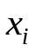 over n is the point estimator used to compute the estimate of the population means, 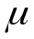.That is 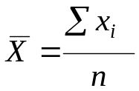is a point estimator of the population mean.

- Confidence interval estimation of the population mean
The confidence level is the probability that the value of the parameter falls within the range specified by the confidence interval surrounding the statistic.
There are different cases to be considered to construct confidence intervals.
Case 1:
If sample size is large or if the population is normal with known variance
Recall the Central Limit Theorem, which applies to the sampling distribution of the mean of a sample. Consider samples of size n drawn from a population, whose mean is and standard deviation is 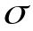with replacement and order important. The population can have any frequency distribution. The sampling distribution of 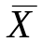will have a mean 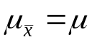and a standard deviation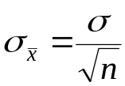, and approaches a normal distribution as n gets large. This allows us to use the normal distribution curve for computing confidence intervals. 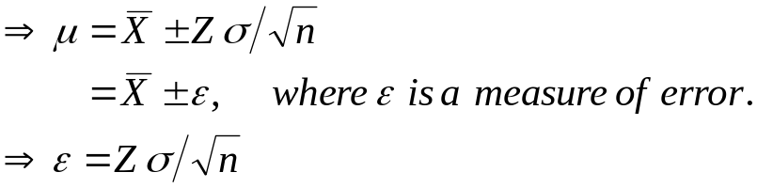
- For the interval estimator to be good the error should be small. How it be small?
      - By making n large
      - Small variability
      - Taking Z small
- To obtain the value of Z, we have to attach this to a theory of chance. That is, there is an area of size 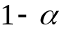 such 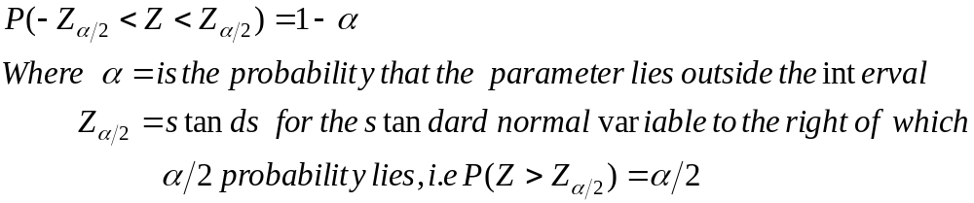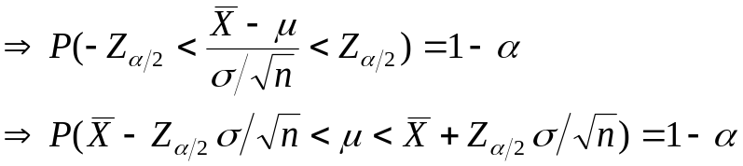
But usually 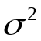 is not known, in that case we estimate by its point estimator S²
Here are the z values corresponding to the most commonly used confidence levels.
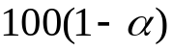% | 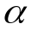 | 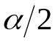 | 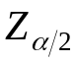
90 | 0.10 | 0.05 | 1.645
95 | 0.05 | 0.025 | 1.96
99 | 0.01 | 0.005 | 2.58

Case 2:
If sample size is small and the population variance, is not known.
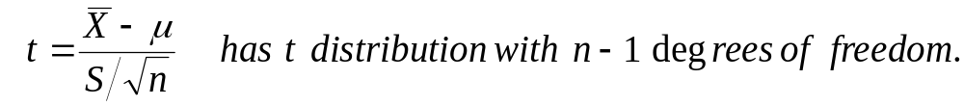
The unit of measurement of the confidence interval is the standard error. This is just the standard deviation of the sampling distribution of the statistic.
Examples:
- From a normal sample of size 25 a mean of 32 was found .Given that the population standard deviation is 4.2. Find
  - A 95% confidence interval for the population mean.
  - A 99% confidence interval for the population mean. (Exercise)
Solution:
- 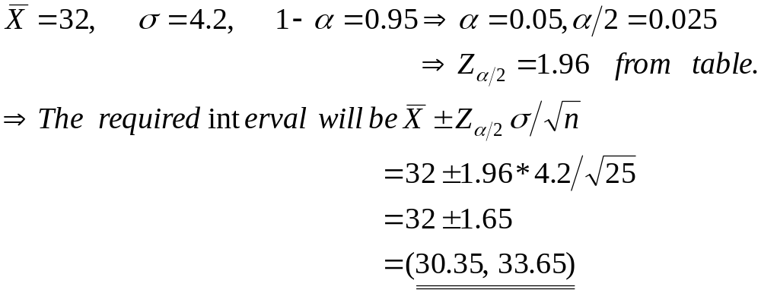
- A drug company is testing a new drug which is supposed to reduce blood pressure. From the six people who are used as subjects, it is found that the average drop in blood pressure is 2.28 points, with a standard deviation of .95 points. What is the 95% confidence interval for the mean change in pressure?
Solution:
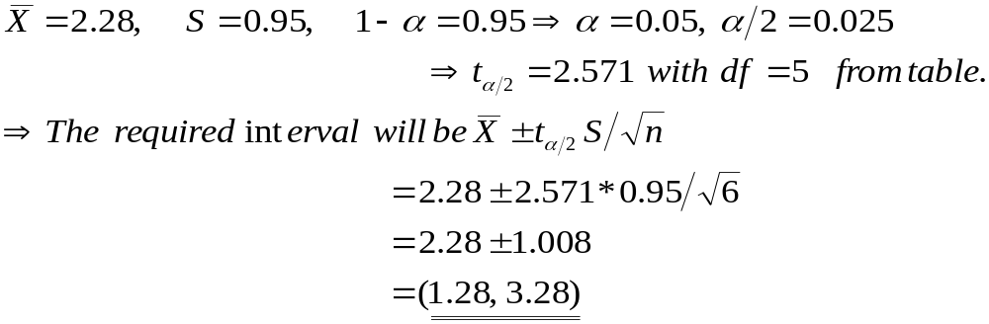That is, we can be 95% confident that the mean decrease in blood pressure is between 1.28 and 3.28 points.
Hypothesis Testing
- This is also one way of making inference about population parameter, where the investigator has prior notion about the value of the parameter.
Definitions:
- Statistical hypothesis: is an assertion or statement about the population whose plausibility is to be evaluated on the basis of the sample data.
- Test statistic: is a statistics whose value serves to determine whether to reject or accept the hypothesis to be tested. It is a random variable.
- Statistic test: is a test or procedure used to evaluate a statistical hypothesis and its value depends on sample data.
There are two types of hypothesis:
Null hypothesis:
- It is the hypothesis to be tested.
- It is the hypothesis of equality or the hypothesis of no difference.
- Usually denoted by H₀.
Alternative hypothesis:
- It is the hypothesis available when the null hypothesis has to be rejected.
- It is the hypothesis of difference.
- Usually denoted by H₁ or H_{a}.

Types and size of errors:
- Testing hypothesis is based on sample data which may involve sampling and non sampling errors.
- The following table gives a summary of possible results of any hypothesis test:
 |  |  | Decision
 |  |  | Reject H₀ | Don't reject H₀
 | Truth | H₀ | Type I Error | Right Decision
 | Truth | H₁ | Right Decision | Type II Error

- Type I error: Rejecting the null hypothesis when it is true.
- Type II error: Failing to reject the null hypothesis when it is false.
NOTE:
- There are errors that are prevalent in any two choice decision making problems.
- There is always a possibility of committing one or the other errors.
- Type I error () and type II error (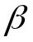) have inverse relationship and therefore, can not be minimized at the same time.
  - In practice we set at some value and design a test that minimize. This is because a type I error is often considered to be more serious, and therefore more important to avoid, than a type II error.
General steps in hypothesis testing:
    - The first step in hypothesis testing is to specify the null hypothesis (H₀) and the alternative hypothesis (H₁).
    - The next step is to select a significance level,
    - Identify the sampling distribution of the estimator.
    - The fourth step is to calculate a statistic analogous to the parameter specified by the null hypothesis.
    - Identify the critical region.
    - Making decision.
    - Summarization of the result.
Hypothesis testing about the population mean,:
Suppose the assumed or hypothesized value of is denoted by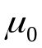, then one can formulate two sided (1) and one sided (2 and 3) hypothesis as follows:
- 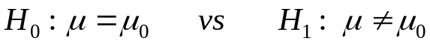
- 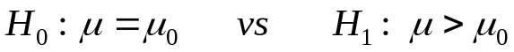
- 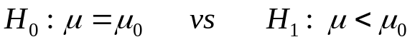
CASES:
Case 1: When sampling is from a normal distribution with known
- The relevant test statistic is
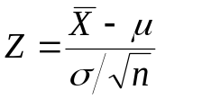
- After specifying we have the following regions (critical and acceptance) on the standard normal distribution corresponding to the above three hypothesis.
H₀ | Reject H₀ if | Accept H₀ if | Inconclusive if
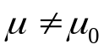 | 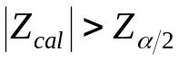 | 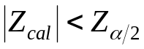 | 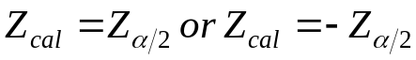
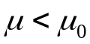 | 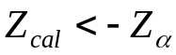 | 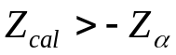 | 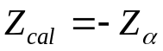
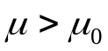 | 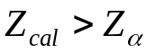 | 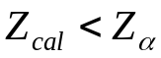 | 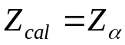

Where: 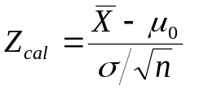
Case 2: When sampling is from a normal distribution with unknown and small sample size
- The relevant test statistic is
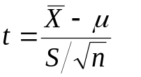~
- After specifying we have the following regions on the student t-distribution corresponding to the above three hypothesis.
H₀ | Reject H₀ if | Accept H₀ if | Inconclusive if
 | 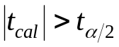 | 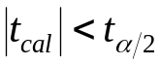 | 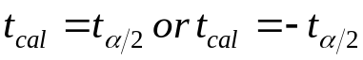
 | 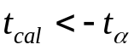 | 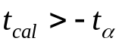 | 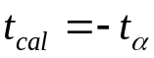
 | 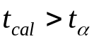 | 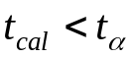 | 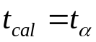

Where: 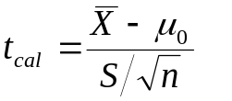

Case3: When sampling is from a non- normally distributed population or a population whose functional form is unknown.
- If a sample size is large one can perform a test hypothesis about the mean by using:

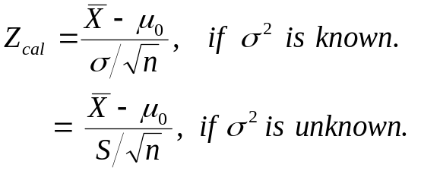

- The decision rule is the same as case I.
Examples:
- Test the hypotheses that the average height content of containers of certain lubricant is 10 liters if the contents of a random sample of 10 containers are 10.2, 9.7, 10.1, 10.3, 10.1, 9.8, 9.9, 10.4, 10.3, and 9.8 liters. Use the 0.01 level of significance and assume that the distribution of contents is normal.

Solution:
Let 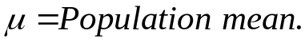 , 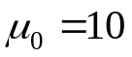
Step 1: Identify the appropriate hypothesis
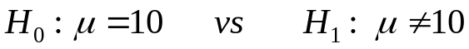
Step 2: select the level of significance, 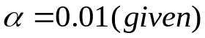
Step 3: Select an appropriate test statistics
t- Statistic is appropriate because population variance is not known and the sample size is also small.
Step 4: identify the critical region.
Here we have two critical regions since we have two tailed hypothesis
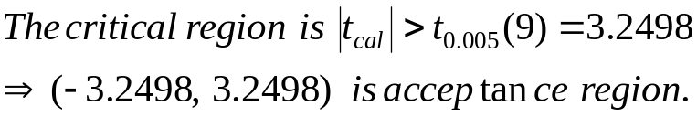
Step 5: Computations:
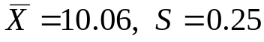
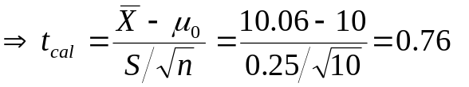
Step 6: Decision
Accept H₀ , since t_{cal} is in the acceptance region.
Step 7: Conclusion
At 1% level of significance, we have no evidence to say that the average height content of containers of the given lubricant is different from 10 litters, based on the given sample data.
- The mean life time of a sample of 16 fluorescent light bulbs produced by a company is computed to be 1570 hours. The population standard deviation is 120 hours. Suppose the hypothesized value for the population mean is 1600 hours. Can we conclude that the life time of light bulbs is decreasing?
(Use 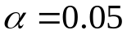 and assume the normality of the population)

Solution:
Let , 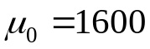
Step 1: Identify the appropriate hypothesis
Step 2: select the level of significance, 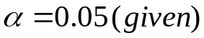
Step 3: Select an appropriate test statistics
Z- Statistic is appropriate because population variance is known.

Step 4: identify the critical region.
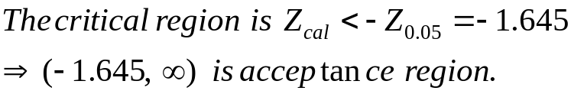
Step 5: Computations:
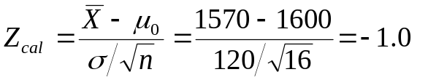
Step 6: Decision
Accept H₀ , since Z_{cal} is in the acceptance region.
Step 7: Conclusion
At 5% level of significance, we have no evidence to say that that the life time of light bulbs is decreasing, based on the given sample data.

Test of Association

- Suppose we have a population consisting of observations having two attributes or qualitative characteristics say A and B.
- If the attributes are independent then the probability of possessing both A and B is P_{A}*P_{B}
Where P_{A} is the probability that a number has attribute A.
P_{B} is the probability that a number has attribute B.

- Suppose A has mutually exclusive and exhaustive classes.
B has mutually exclusive and exhaustive classes
- The entire set of data can be represented using 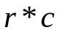 contingency table.

B
A | B₁ | B₂ | . | . | B_{j} | . | B_{c} | Total
A₁ | O₁₁ | O₁₂ |  |  | O_{1j} |  | O_{1c} | R₁
A₂ | O₂₁ | O₂₂ |  |  | O_{2j} |  | O_{2c} | R₂
.
.
A_{i} | O_{i1} | O_{i2} |  |  | O_{ij} |  | O_{ic} | R_{i}
.
.
A_{r} | O_{r1} | O_{r2} |  |  | O_{rj} |  | O_{rc}
Total | C₁ | C₂ |  |  | C_{j} |  |  | n
- The chi-square procedure test is used to test the hypothesis of independency of two attributes .For instance we may be interested
    - Whether the presence or absence of hypertension is independent of smoking habit or not.
    - Whether the size of the family is independent of the level of education attained by the mothers.
    - Whether there is association between father and son regarding boldness.
    - Whether there is association between stability of marriage and period of acquaintance ship prior to marriage.

- The 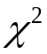 statistic is given by:
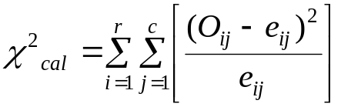 ~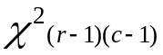
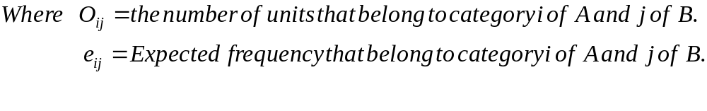
- The 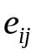 is given by :
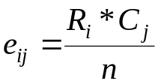
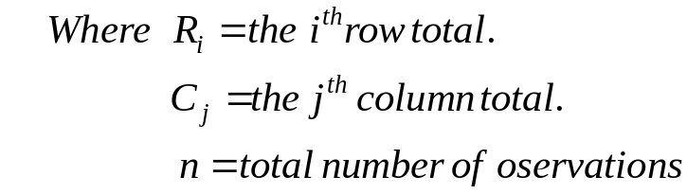

Remark:
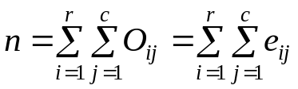
- The null and alternative hypothesis may be stated as:
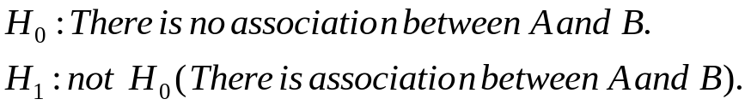
Decision Rule:

- Reject H₀ for independency at level of significance if the calculated value of exceeds the tabulated value with degree of freedom equal to 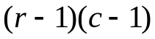.
Reject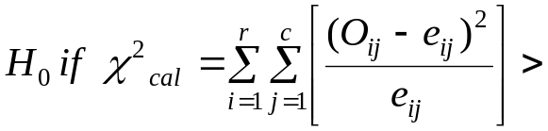 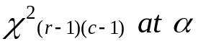

Examples:
- A geneticist took a random sample of 300 men to study whether there is association between father and son regarding boldness. He obtained the following results.

Son
Father | Bold | Not
Bold | 85 | 59
Not | 65 | 91
Using 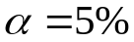 test whether there is association between father and son regarding boldness.
Solution:
  - First calculate the row and column totals
  - Then calculate the expected frequencies( e_{ij}’s)
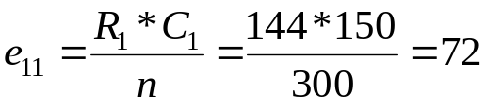
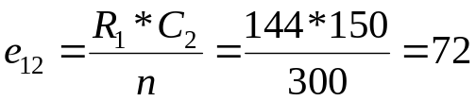

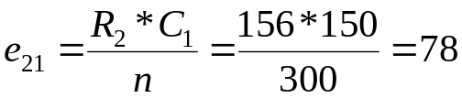
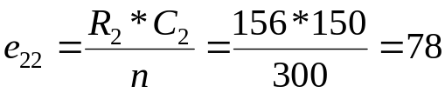
  - Obtain the calculated value of the chi-square.
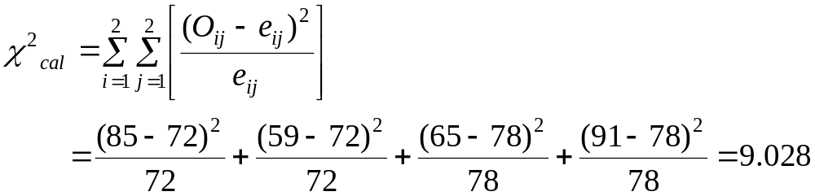

  - Obtain the tabulated value of chi-square
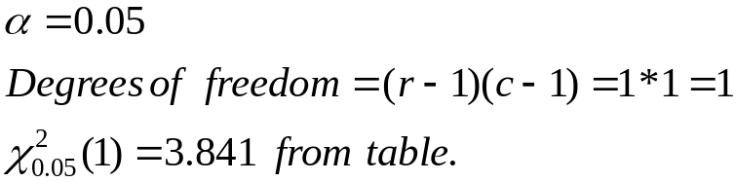
  - The decision is to reject H₀ since 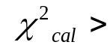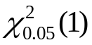
Conclusion: At 5% level of significance we have evidence to say there is association between father and son regarding boldness, based on this sample data.

